**Healthy School Meals for All NY Kids Social Media Toolkit**

Over the last two years, the Healthy School Meals for All New York Kids Coalition has secured major expansions of free school meals, but hundreds of schools are still unable to provide free school meals to all of their students. It’s time for New York to close the gap and provide access to school meals at no cost to all of our state’s students.

In her FY2026 Executive Budget, Governor Kathy Hochul included full funding for a statewide universal free school meals program. The Legislature has championed this important investment for the past two years. Now, as budget negotiations move forward, we must urge legislative leaders and the Governor to ensure Healthy School Meals for All remains fully funded in the final state budget.

Below are sample captions and graphics you can use on your preferred social media platform. We are grateful for your support of this critical initiative!

**Sample captions start on** **page 7.**

**Images**

* Right-click on an image to save it to your computer

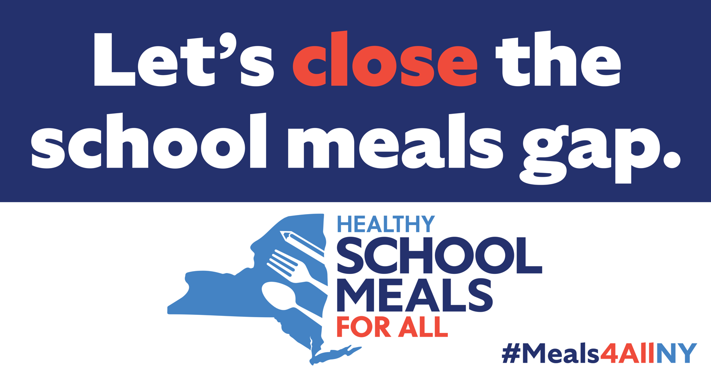

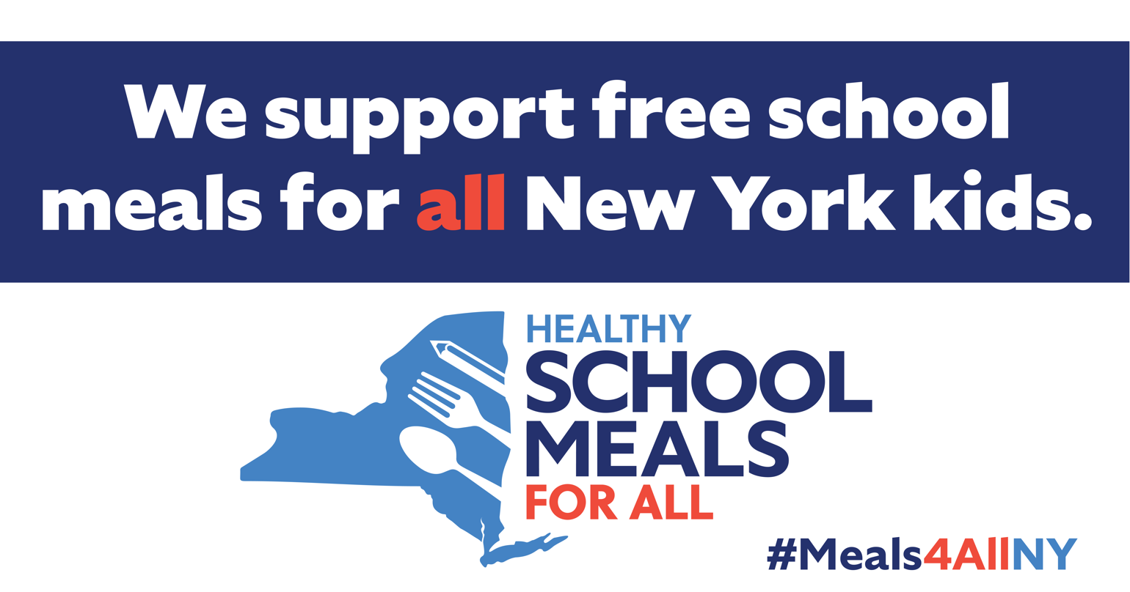

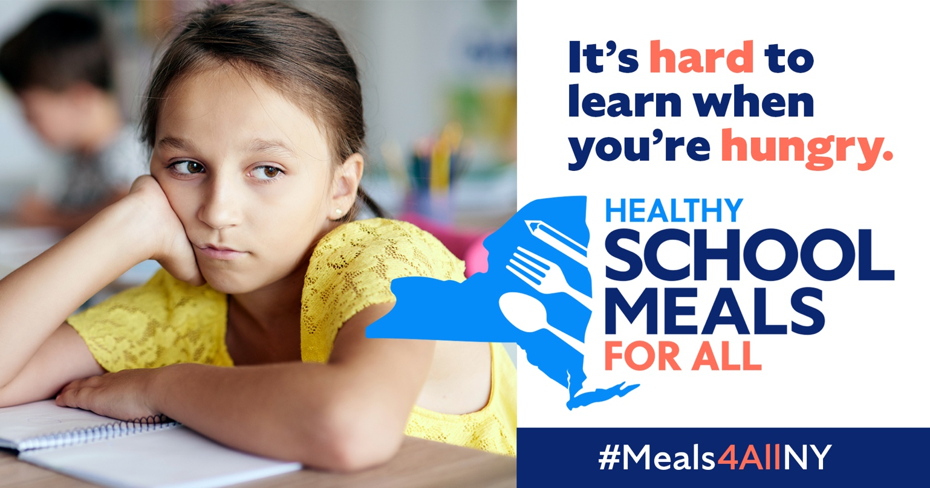

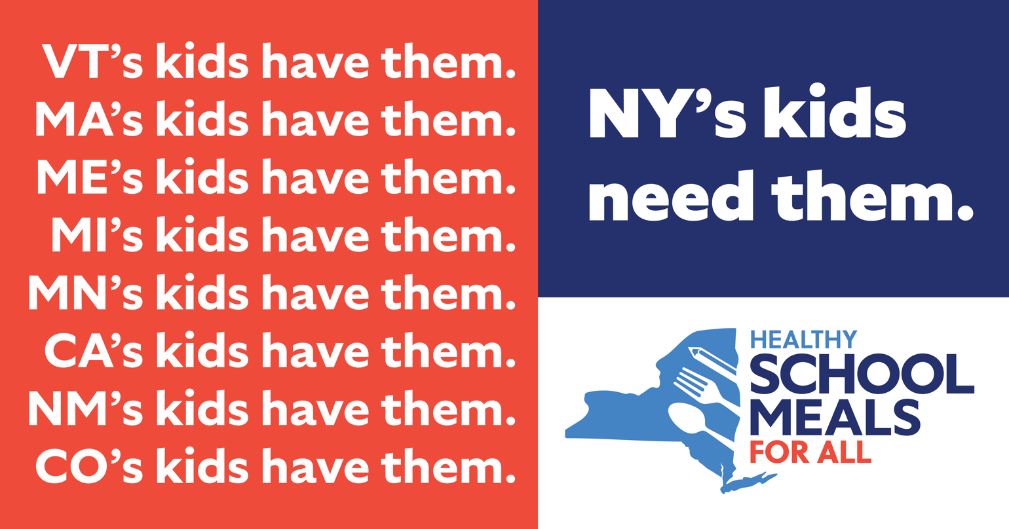

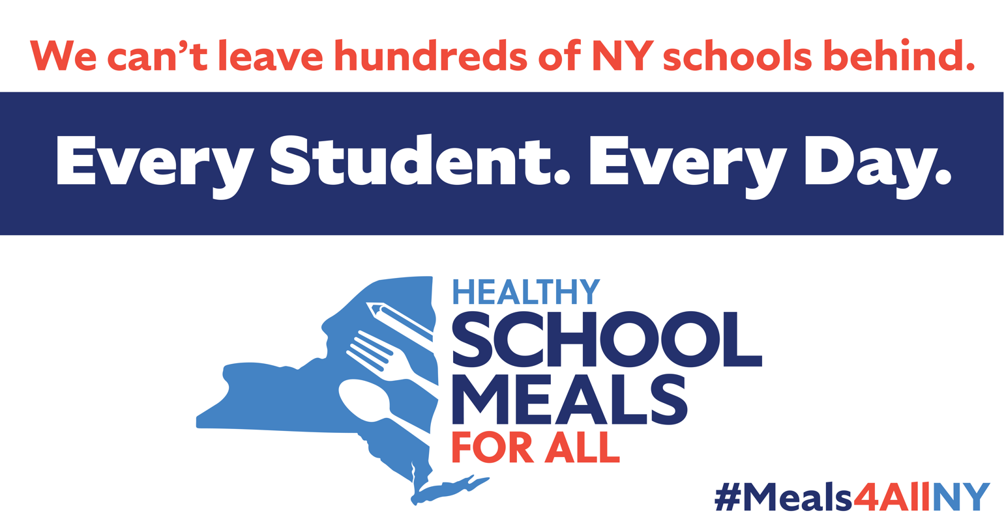

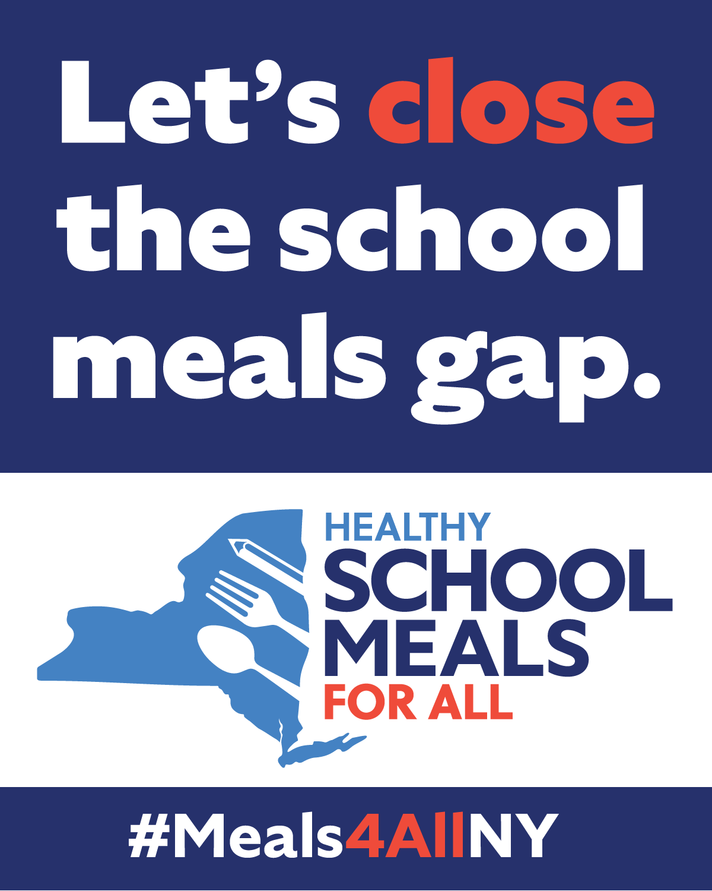

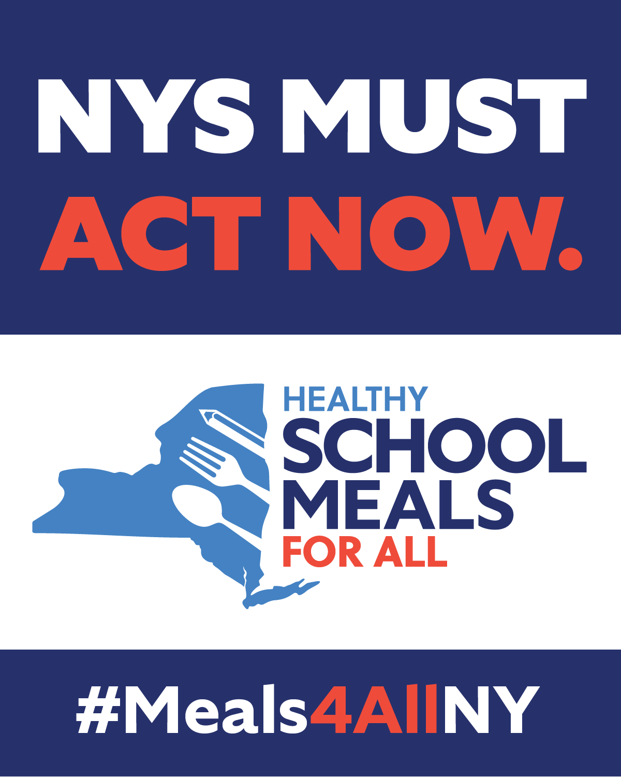

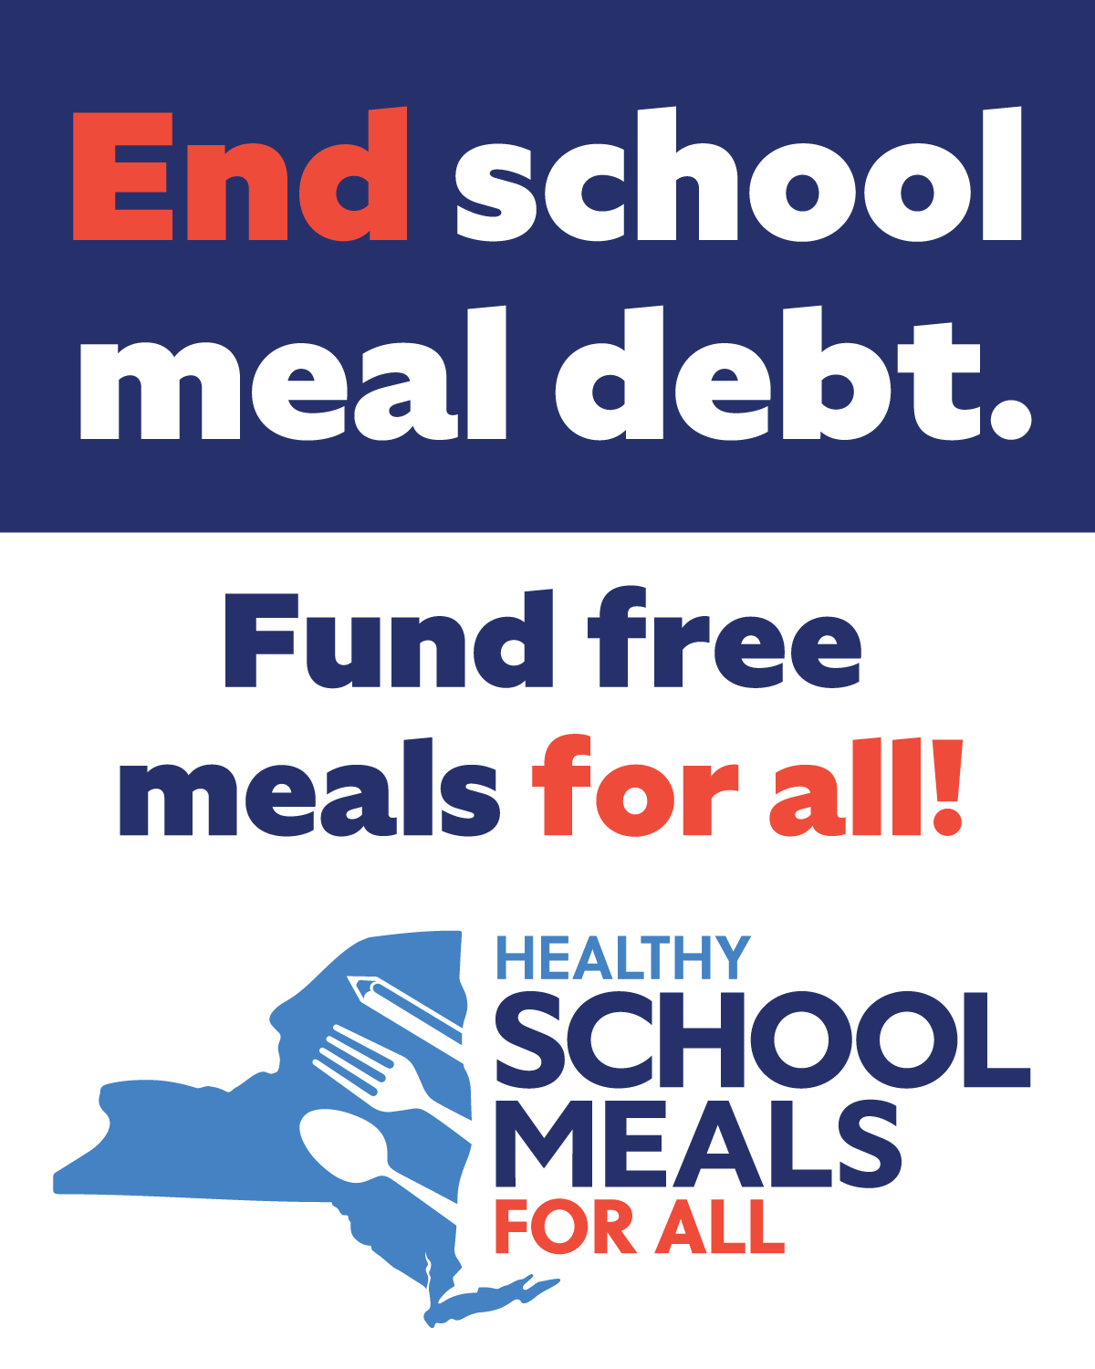

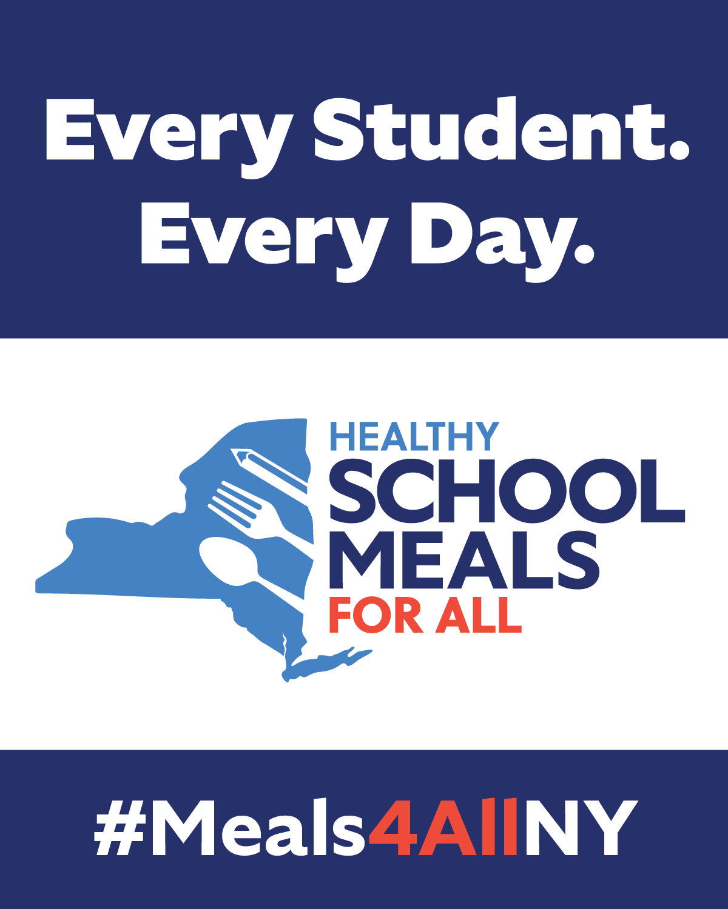

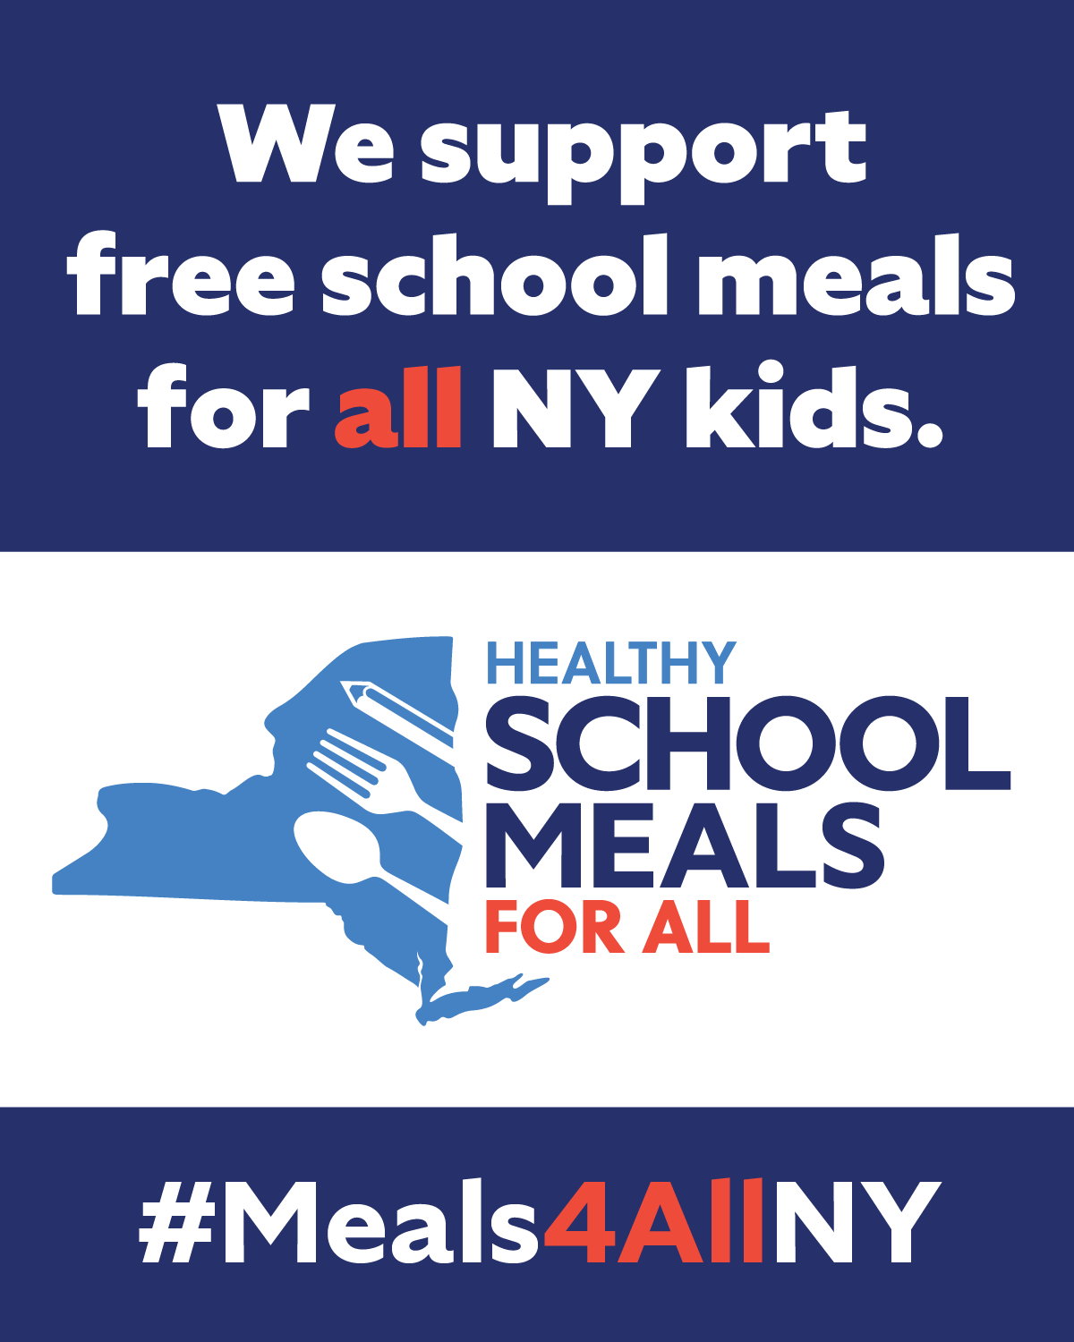

# Shorter Captions Thank you @GovKathyHochul for including universal school meals in your Executive Budget! Now, with the ongoing support of the NYS Senate & Assembly, we must get this critical investment across the finish line. @CarlHeastie @AndreaSCousins let’s make #Meals4AllNY a reality!

# Free school meals = a more affordable NY! NY leaders can provide meaningful financial relief for NY families by fully funding #Meals4AllNY in the final state budget. SchoolMealsForAllNY.org

# DYK: When kids get free school breakfast & lunch, families’ grocery costs decrease by up to 19%. #Meals4AllNY makes NY more affordable while also supporting kids’ learning & mental health. Let’s get it across the finish line! SchoolMealsForAllNY.org

# No child should miss out on a healthy school breakfast & lunch because of stigma—but many do. New York can end unequal access to free school meals by fully funding #Meals4AllNY. Learn more: SchoolMealsForAllNY.org

# When school meals are not free for all students, the kids who need them most choose not to eat. #Meals4AllNY levels the playing field and creates equity in cafeterias so students feel comfortable getting the food they need at school. SchoolMealsForAllNY.org

# 87% of surveyed New York parents support free school meals for all students. The benefits to families are clear: free school meals save time, money, and stress. #Meals4AllNY is a policy that New Yorkers want and families need. Learn more: SchoolMealsForAllNY.org

# Universal school meals equip schools with the capacity and financial support to diversify their menus and offer more local food in cafeterias. #Meals4AllNY is not only a win-win for kids and families but also for farmers and small businesses. Learn more: SchoolMealsForAllNY.org

# With support from @GovKathyHochul @CarlHeastie & @AndreaSCousins, NY is on track to become the ninth state to provide universal free school breakfast & lunch! Let’s get it across the finish line in the FY26 final budget. SchoolMealsForAllNY.org

# How can we help all NY students succeed? Offer free school meals for all. Universal school meals would ensure 2.7M students in our state have the food they need to thrive. Let’s make #Meals4AllNY a reality in the final budget! SchoolMealsForAllNY.org

# Long division is hard. Doing long division when you’re hungry is even harder. With universal school meals, NY can ensure all 2.7M kids have the food they need to focus & engage in the classroom. Let’s make #Meals4AllNY a reality in the FY26 final budget! SchoolMealsForAllNY.org

# Hunger disproportionately impacts communities of color. Learn how #Meals4AllNY can alleviate food insecurity by ensuring equitable access to healthy meals at school. SchoolMealsForAllNY.org

# 1 in 5 kids in New York experiences hunger & many rely on school meals as a consistent source of nutrition. The upcoming state budget is a critical opportunity to get #Meals4AllNY across the finish line & support food security for NY kids.SchoolMealsForAllNY.org

# School meals are as important to academic success as textbooks and teachers. NY can close the school meals gap by fully funding #Meals4AllNY in the final state budget. Learn more: SchoolMealsForAllNY.org

# Longer Captions

# We’re thrilled @Governor Kathy Hochul included universal school meals in her FY2026 Executive Budget! The NYS Senate and Assembly have championed this critical investment for the past two years, and now we can make it a reality. This policy will alleviate hunger, support children’s learning and health, and put money back in parents’ pockets. As budget negotiations move forward, we urge NY leaders to ensure #Meals4AllNY remains fully funded in the final budget. Learn more: SchoolMealsForAllNY.org

# With support from the Governor and strong legislative champions, NY is on track to become the ninth state to provide universal school breakfast and lunch! This investment will close the school meals gap for more than 280,000 students across 600 schools. We urge NY leaders to prioritize #Meals4AllNY in final budget negotiations to ensure all kids have the food they need to learn and thrive. Learn more: SchoolMealsForAllNY.org